Network Testing Practical
- Connect your laptop and a friend's phone to the same Wi-Fi network, then use the ping command to check if both devices can communicate with each other. Hint: On Windows, use 'ping [IP address]' in Command Prompt; on Android, try a ping app or use Termux.

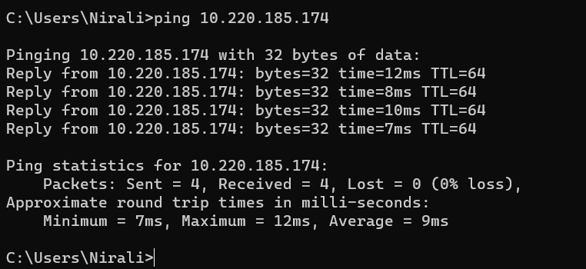
Fig 1. Check that Devices in same network is communicating

- Run the traceroute (tracert on Windows or traceroute on Mac/Linux) command to www.youtube.com from your device and note down the number of hops it takes to reach the destination.

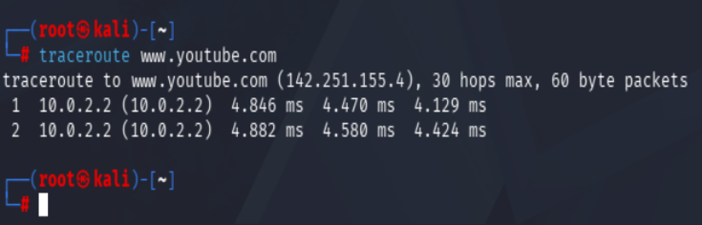Fig 2. Traceroute command

- Disconnect one device from the Wi-Fi, then try pinging it again from your laptop and describe the error message you receive.

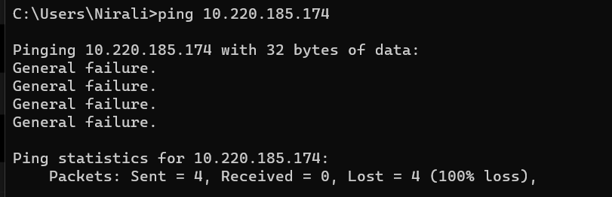
Fig 3. Pinging fail error

- Create a simple table listing the IP addresses of all devices connected to your home Wi-Fi (use 'arp -a' on Windows), and identify which device belongs to which person or gadget.

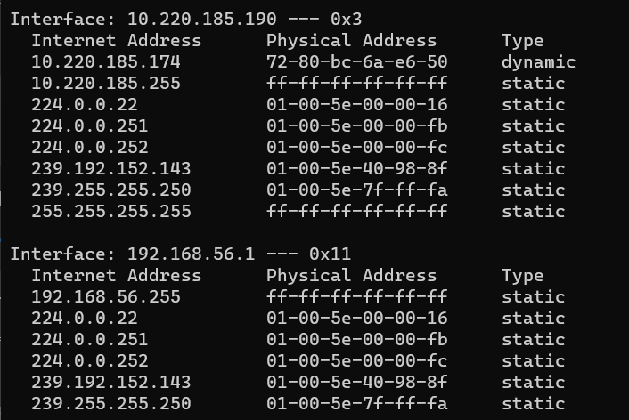
Fig 4. List of devices connected to the Wi-Fi

- Write a one-page report explaining step-by-step how you set up the network, tested connectivity using ping and traceroute, and what results or issues you observed. Hint: Include screenshots or command outputs if possible.

1. Objective
- To set up a small network.
- To test network connectivity using Ping.
- To check the network path using Traceroute.
2. Network Setup
- Connected my laptop and mobile phone to the same network.
- Checked the laptop's IP address using the ipconfig command.
- Verified the IP address, subnet mask, and default gateway.
- Confirmed that the internet connection was working.
3. Ping Test
- Opened Command Prompt.
- Ran the ping command using the target device's IP address.
- Verified whether the devices could communicate.
- Disconnected the phone from the Wi-Fi network.
- Ran the ping command again.
- Received the "General failure" error message.
4. Traceroute Test
- Opened the Terminal in Kali Linux.
- Ran the command:
traceroute www.youtube.com
- Observed the path (hops) from my device to YouTube.
- Counted the total number of hops.
5. Results
- The network was connected successfully.
- The Ping command checked communication between devices.
- After disconnecting the phone, Ping failed with "General failure".
- The Traceroute command displayed the route taken by the packets.
6. Issues Observed
- Ping failed after the device was disconnected.
- The error message displayed was "General failure".
- The number of hops in Traceroute depends on the internet network.
7. Conclusion
- Learned how to set up a basic network.
- Learned how to use Ping to test connectivity.
- Learned how to use Traceroute to view the network path.
- Understood that disconnected devices cannot communicate on the network.

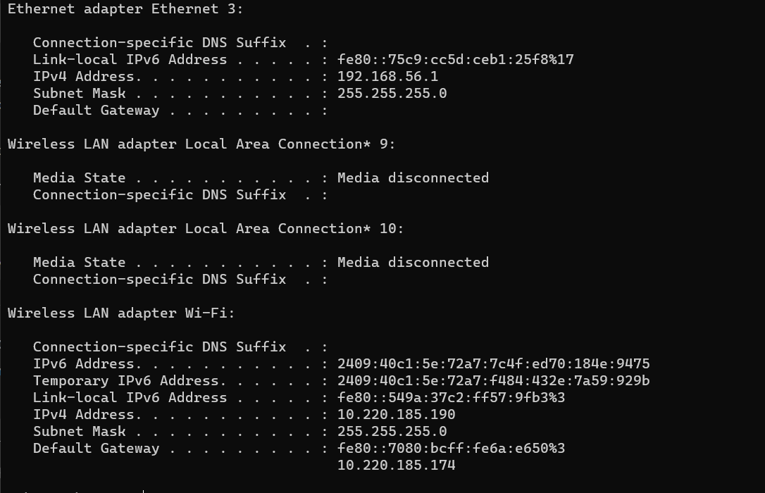
Fig 5. IP Configuration

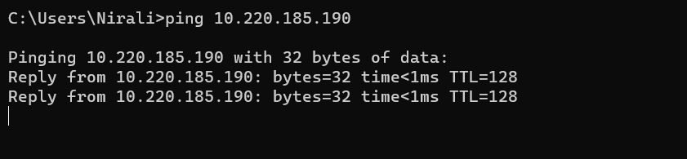
Fig 6. Pinging Device

Fig 7. Traceroute
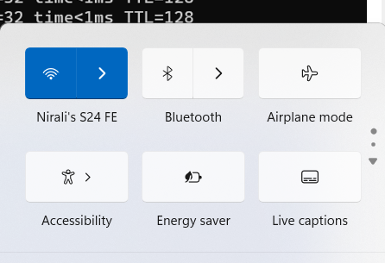
Fig 8. WiFi Connection

